Unified Mechanics · Observer-Readout Closure

The Snowflake Realisation Closure Theorem
Codimension-One Rendering, Gauss–Bonnet Readout, and Vacuum Stress from the 240-Root Residual in Unified Mechanics
Joseph Shields
July 2026

Abstract. This paper closes the observer-readout segment of Unified Mechanics from the internally normalized 240-root residual to an externally realized constant-curvature term. The central correction is that the $E_{8}$ root system does not require, and does not contain, a 241st root. The old $240+1$ intuition is retyped as a change of mathematical kind: 240 internal root contractions are followed by one codimension-one realization of the completed boundary. The local observer carrier is derived from the Unified Mechanics three-channel grammar. Three permutation-equivalent bidirectional channel directions, represented with no unforced independent coordinate and zero directional remainder, uniquely produce the rank-two $A_{2}$ snowflake. Its primitive covolume in the standard simply-laced normalization is $\sqrt{3}$. An independently verified exact-cover certificate shows that the 240 $E_{8}$ roots can be exhausted by forty disjoint $A_{2}$ cells, so no root remainder is left. Rendering a rank-two boundary as a closed three-dimensional object contributes one normal relation, $T_{p}Σ⊕N_{p}Σ$ with ranks $2+1=3$. Under the Unified Mechanics minimal-topology condition, the closed connected orientable boundary has genus zero and is therefore topologically $S^{2}$. The global factor $4π$ is then derived without choosing a unit radius: Gauss–Bonnet gives Σ​K dA=2πχΣ=4π. Defining the observer response two-form by $ω_{∂}=\left(r^{240}/\sqrt{3}\right)K dA$ yields
λ∂=Σ​ω∂=4π3r240=2.8603331361×10−122.
Because this record is topological, scalar, and constant under smooth deformations that preserve the completed boundary type, its zeroth-derivative covariant realization is a cosmological-constant term. Variation gives $T_{μν}^{\left(∂\right)}=−ε_{∂}g_{μν}$ and $w=−1$. Combining this amplitude with the independent Unified Mechanics density remainder $Ω_{DE}=0.6883222261$ gives $H_{0}=67.3617 km s^{−1} Mpc^{−1}$. The result is a conditional closure theorem: the segment is internally complete once the stated Unified Mechanics representation conditions are accepted. The empirical selection of the $E_{8}$ carrier, root-state factorization, and a constant rather than evolving dark-energy background remain tests of the wider framework.

1. The closure problem
Unified Mechanics already contains two distinct cosmological constructions.
The first is a completed density accounting:
$$Ω_{b}=\frac{r^{2}}{2}, Ω_{DM}=4r^{2}\left(1−r\right),$$
$$\boxed{Ω_{DE}=1−\frac{r^{2}}{2}−4r^{2}\left(1−r\right)=0.6883222261…}.$$
The second is a vacuum-scale residual produced by a factorized contraction over the 240 roots of the first $E_{8}$ shell:
$$\boxed{P_{int}=r^{240}}.$$
Here
$$φ=\frac{1+\sqrt{5}}{2}, r=\frac{1}{2φ}=0.3090169943749474….$$
The density remainder is a fraction of the cosmological budget. The root residual is an absolute hierarchy relative to the fundamental scale. They are not the same quantity. The missing segment has therefore always been a representation map:
$$\text{completed internal root event}→\text{one externally recorded curvature scalar}.$$
The older reader represented this missing step as $r^{241}$ or as a fourth traversal. That language correctly detected that internal completion was not yet external realization, but it typed the additional operation as another root-like contraction. The present paper corrects that type error.
CENTRAL CORRECTION. $E_{8}$ has exactly 240 roots. The final realization is not a 241st root and does not automatically multiply the residual by another factor of $r$. It is a codimension-one boundary operation whose mathematical action is geometric and topological rather than another internal traversal.
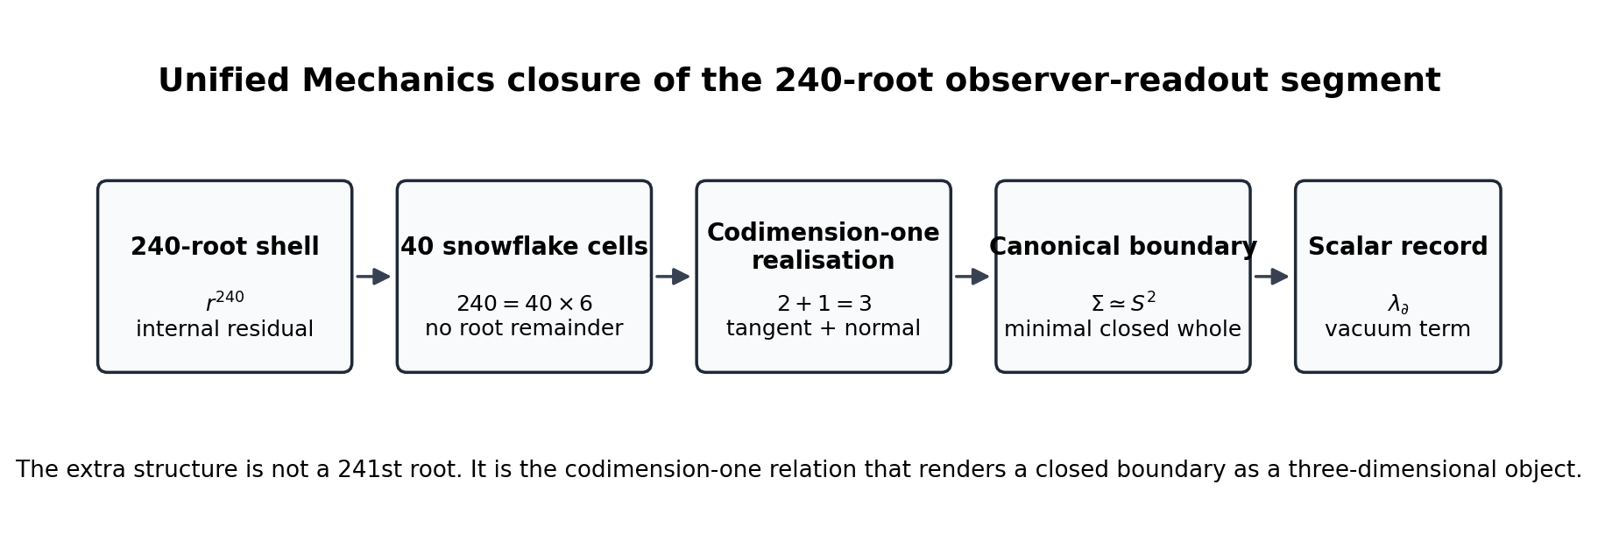
The final segment changes mathematical type: root execution becomes boundary realization and then a scalar record.

2. The representation conditions
The closure theorem will use six conditions already native to the Unified Mechanics architecture. They are stated explicitly so that the conclusion is neither hidden in terminology nor fitted after the numerical comparison.

2.1 Internal residual condition
Let $Φ\left(E_{8}\right)$ be the 240-root shell. A primitive contraction event of marginal weight $r$ is assigned to each root and the root-state carrier factorizes at the vacuum readout:
$$ρ_{Φ}=⨂_{α∈Φ\left(E_{8}\right)}ρ_{r}.$$
The joint contracted event is then
Pint=α∈ΦE8​r=r240.
This condition belongs upstream of the present paper. The present paper does not rederive the physical selection of $E_{8}$ or the factorization hypothesis; it closes the observer segment after that internal residual is admitted.

2.2 Minimal three-channel carrier condition
The three quotient classes of the Unified Mechanics execution algebra are represented as three distinct observer-facing channel directions. Their geometric carrier is permutation-covariant before the unequal physical weights $W_{L},W_{B},W_{M}$ are attached. Thus equality refers to carrier norm, not to channel amplitude.
The representation introduces no unforced independent direction. The three channel directions therefore live in the smallest real inner-product space capable of distinguishing all three while permitting closure: a rank-two plane.

2.3 Bidirectionality and zero directional remainder
Every channel relation admits both orientations. The completed local cell has no preferred outgoing direction:
$$β_{L}+β_{B}+β_{M}=0.$$

2.4 Exhaustive root rendering condition
The complete 240-root shell must be renderable through the local channel carrier without unused roots. The supplied exact-cover certificate demonstrates one such exhaustive rendering by forty disjoint six-root cells.

2.5 Canonical whole condition
The observer-facing object is represented by a compact, connected, orientable, codimension-one boundary. Canonicalization adds no unforced topological generators. In a closed orientable surface, each handle introduces independent noncontractible cycles; the canonical whole therefore has genus zero.

2.6 Scalar persistence condition
A completed global boundary record is shared by every background realization of the same whole and is invariant under smooth deformations that preserve its topology. Its lowest-order covariant realization is therefore a spacetime-constant scalar term.
THEOREM 1 — Conditional Snowflake Realisation Closure. Under Conditions 2.1–2.6, the observer-readout segment is uniquely fixed by
ω∂=r2403K dA, λ∂=Σ​ω∂=4π3r240.
The completed record enters the covariant action as a constant vacuum term and produces $T_{μν}^{\left(∂\right)}=−ε_{∂}g_{μν}$.
The rest of the paper proves each arrow in this statement.

3. Why the local carrier is the snowflake

3.1 Three equal carrier directions
Let
$$β_{L}, β_{B}, β_{M}$$
be the three observer-facing channel directions in a real rank-two inner-product space. Permutation covariance fixes a common norm
$$∥β_{L}∥=∥β_{B}∥=∥β_{M}∥=ℓ$$
and a common pairwise inner product
$$β_{i}⋅β_{j}=d \left(i≠j\right).$$
The zero-remainder condition gives
$$0=∥β_{L}+β_{B}+β_{M}∥^{2}=3ℓ^{2}+6d,$$
hence
$$d=−\frac{ℓ^{2}}{2}.$$
Therefore
$$cosθ=\frac{d}{ℓ^{2}}=−\frac{1}{2},$$
so every pair meets at ${120}^{∘}$.
Including reverse orientations gives
$$S=\{±β_{L},±β_{B},±β_{M}\},$$
a regular six-root hexagon.
THEOREM 2 — Unique Minimal Three-Channel Boundary Carrier. Up to an overall scale and orthogonal transformation, the unique rank-two, permutation-covariant, bidirectional representation of three channel directions with zero directional remainder is the $A_{2}$ root geometry.
The word snowflake is therefore only a visual name for the forced local carrier:
$$3\text{ channel axes}×2\text{ orientations}=6\text{ roots}.$$

3.2 Unequal channel weights do not deform the carrier
Unified Mechanics assigns the three physical weights
$$W_{L}={\left(1−r\right)}^{2}, W_{B}=2r\left(1−r\right), W_{M}=r^{2}.$$
These weights are coefficients carried along the three directions. They need not be encoded as unequal root lengths. The local geometric carrier records relational type; amplitudes record realized occupancy or coupling. Formally, a local channel state may be written
$$Ψ=W_{L}β_{L}+W_{B}β_{B}+W_{M}β_{M}.$$
The carrier remains $A_{2}$ while the physical state on that carrier is anisotropically weighted. This separation avoids the false objection that the three-channel values are unequal and therefore cannot sit on an equal snowflake geometry.

4. Why the primitive unit is $\sqrt{3}$
Use the standard simply-laced root normalization
$$∥β_{1}∥^{2}=∥β_{2}∥^{2}=2, β_{1}⋅β_{2}=−1.$$
The primitive boundary cell is the parallelogram generated by the two independent simple roots. Its squared area is the Gram determinant:
$$A_{A_{2}}^{2}=det\left(\begin{matrix}2 & −1 \\ −1 & 2\end{matrix}\right)=3.$$
Thus
$$\boxed{A_{A_{2}}=\sqrt{3}}.$$
The full outline hexagon has area $3\sqrt{3}$, but it contains three primitive cells. Using the hexagon area would count the oriented directions as though they were six independent coordinates. The observer boundary has rank two; its irreducible measure is therefore the covolume of two independent generators.
LEMMA 3 — Primitive-Measure Minimality. In a rank-two lattice representation, the canonical local measure is the covolume of an independent basis. Any larger polygonal area is an integer multiple of that primitive measure and adds unforced multiplicity. Therefore the minimal $A_{2}$ observer unit is $\sqrt{3}$.

5. Exhausting the 240 roots without a root remainder

5.1 Exact-cover result
The standard $E_{8}$ root coordinates contain 240 norm-two roots. Every pair $α,β$ with
$$α⋅β=−1$$
generates a six-root $A_{2}$ subsystem
$$\{±α,±β,±\left(α+β\right)\}.$$
All such candidate cells were enumerated. A binary exact-cover problem was then solved and independently verified. The supplied certificate contains forty cells satisfying
$$40×6=240,$$
with every standard $E_{8}$ root appearing exactly once.
The certificate verification returns:
- 40 disjoint $A_{2}$ cells;
- 240 distinct roots;
- exact equality with the standard $E_{8}$ root set.
The certificate SHA-256 hash is
79d67c554443a1ffdd94e1256783aa756819efae6f3ca798fd3983c4bc8a815b.

5.2 What the exact cover proves
The exact cover proves the existence of a complete local rendering:
$$Φ\left(E_{8}\right)=\underset{a=1}{\overset{40}{⨆}}C_{a}, C_{a}≅A_{2}.$$
Therefore the root-level quantitative remainder is zero:
$$R_{root}=240−40×6=0.$$
That result matters because it prevents the global scalar from being attributed to an unexplained leftover root. Every root is already accounted for.

5.3 Why uniqueness of the cover is unnecessary
The observer readout does not depend on the labels $a=1,…,40$. The internal residual $r^{240}$ is defined before any partition, and every valid $A_{2}$ cell has the same Gram matrix and primitive area $\sqrt{3}$. Consequently a different exact cover, if chosen, cannot alter the local measure or the internal exponent.
LEMMA 4 — Cover Independence. Let $C$ and $C′$ be any exhaustive disjoint $A_{2}$ covers of the same 240-root shell. Because $r^{240}$ is a shell-level joint amplitude and all $A_{2}$ cells have covolume $\sqrt{3}$, the observer response defined below is identical for $C$ and $C′$. Physical closure requires an exhaustive cell type, not a uniquely labelled partition.
This removes the previous need to prove that one particular forty-cell cover is Weyl-canonical.

6. The extra structure is codimension one
The local snowflake is rank two. A two-dimensional carrier by itself is not yet a three-dimensional object. To become the boundary of a volume, it requires a one-dimensional normal relation.
At every regular point $p$ of the realized boundary $Σ$,
$$T_{p}Σ⊕N_{p}Σ≅T_{p}M,$$
with
$$dimT_{p}Σ=2, dimN_{p}Σ=1, dimT_{p}M=3.$$
Therefore
$$\boxed{2+1=3}.$$
The additional one is the normal bundle rank. It distinguishes inside from outside and turns the planar relation into a boundary of a volume. It is not another channel, another $E_{8}$ root, or another multiplicative contraction.
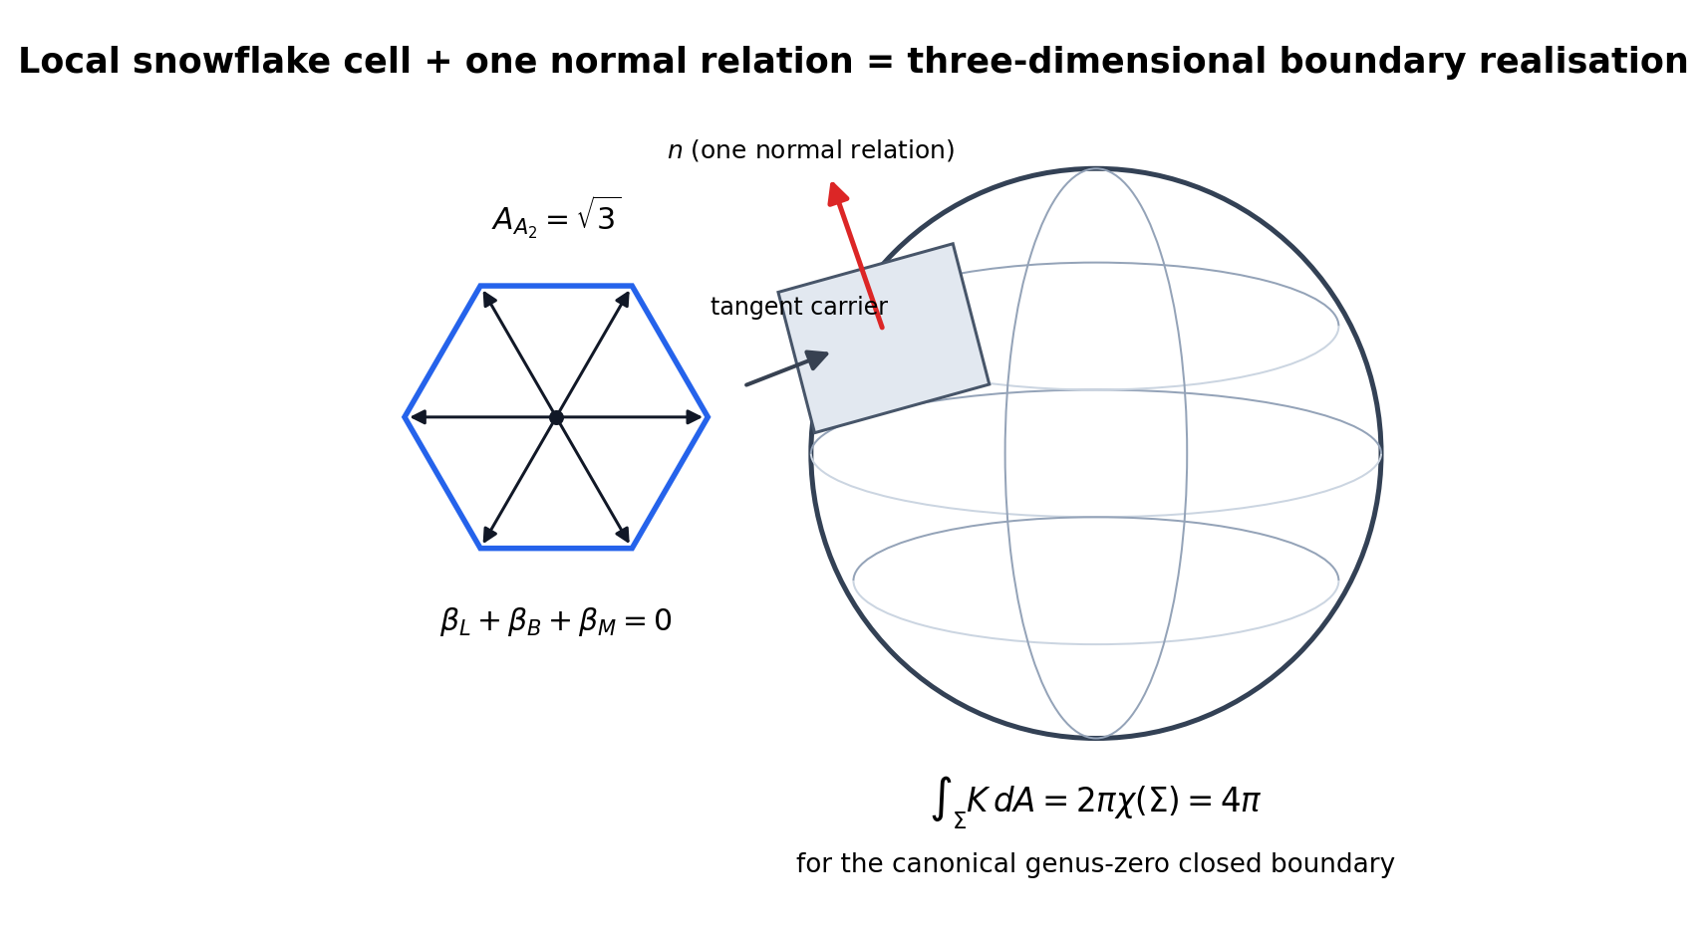
The rank-two snowflake becomes a three-dimensional boundary through one normal relation. The global factor is intrinsic total curvature, not the area of a chosen unit sphere.
THEOREM 5 — Codimension-One Rendering. A regular orientable rank-two boundary carrier realized as the boundary of a three-dimensional whole necessarily acquires one normal line. The old $+1$ is therefore correctly interpreted as one realization relation:
$$240\text{ internal root states}+1\text{ whole-boundary realization},$$
not as 241 roots and not as $r^{241}$.
This is the precise content that the old “fourth traversal” reader was detecting. Three relations close internally; one operation renders their closure as an object.

7. Why the completed boundary is $S^{2}$
A compact connected orientable closed surface is classified by its genus $g$. Its Euler characteristic is
$$χ\left(Σ_{g}\right)=2−2g.$$
Each handle introduces independent noncontractible cycles and therefore additional topological information. The Unified Mechanics canonicalization rule selects the realization that introduces no structure not required by closure. Thus
$$g=0.$$
The unique compact connected orientable genus-zero surface is
$$\boxed{Σ≃S^{2}}.$$
This conclusion does not require the boundary to be a perfectly round geometric sphere. It requires only the topology of a sphere. Local distortions, inhomogeneous metrics, and smooth deformations do not change the genus-zero whole.
THEOREM 6 — Canonical Boundary Topology. A closed connected orientable two-dimensional realization with no unforced topological generators has genus zero and is homeomorphic to $S^{2}$.
The earlier argument used the area $4π$ of a unit sphere. That left a normalization question: why unit radius? The topological formulation removes that freedom.

8. Why the global factor is exactly $4π$
For a compact oriented surface without boundary, Gauss–Bonnet gives
Σ​K dA=2πχΣ.
For the canonical genus-zero boundary,
$$χ\left(S^{2}\right)=2,$$
so
Σ​K dA=4π.
This is intrinsic and scale-free. A round sphere of any radius, an ellipsoid, or any smooth genus-zero deformation has the same integrated Gaussian curvature. The factor $4π$ is therefore not an inserted global area and is not chosen to match the cosmological number. It is the topological curvature charge of the completed boundary.

8.1 The observer response two-form
The exact cover shows that the complete root shell is compatible with a local $A_{2}$ boundary alphabet. The observer quotient forgets internal cell labels and retains the common primitive cell type. The internal shell residual is therefore represented as a response per primitive cell measure:
$$ρ_{cell}=\frac{r^{240}}{A_{A_{2}}}=\frac{r^{240}}{\sqrt{3}}.$$
The natural intrinsic curvature response two-form is
$$\boxed{ω_{∂}=ρ_{cell}K dA=\frac{r^{240}}{\sqrt{3}}K dA}.$$
The global record is the integral over the completed observer boundary:
λ∂=Σ​ω∂.
Gauss–Bonnet then forces
λ∂=r2403Σ​K dA=4π3r240.
THEOREM 7 — Topological Snowflake Readout. For an exhaustive $A_{2}$ rendering of the 240-root residual and a canonical genus-zero observer boundary, the only scale-free intrinsic curvature readout normalized by the primitive local cell is
$$λ_{∂}=\frac{4π}{\sqrt{3}}r^{240}.$$
The factor $4π$ is fixed by topology and the factor $\sqrt{3}$ by the local root Gram determinant.

8.2 Why the result is not multiplied by forty
The exponent $240$ already includes every root. The forty cells are a reorganization of those same factors, not forty new independent vacuum events. Multiplying by forty would count the root shell twice.
The exact cover has one job: prove that the local $A_{2}$ grammar can exhaust the internal structure with no root remainder. The observer quotient then retains one cell type, while Gauss–Bonnet reads one completed global boundary.
The correct sequence is
$$240\text{ roots}→40\text{ local cells}→1\text{ cell type}→1\text{ global curvature integral}.$$

9. The four earlier interpretations fold into one mechanism
The previous discussion produced four views: invariant whole, structural remainder, thermodynamic residue, and cosmological background. They are not four independent sources. They are successive representations of one completed system.
Whole. The mathematical object is the closed genus-zero boundary $Σ$. Its physical role is to present one completed observer object.
Structural remainder. The mathematical object is the normal line $N_{p}Σ$. Its physical role is to turn a rank-two plane into the boundary of a volume.
Residue. The mathematical object is
λ∂=Σ​ω∂.
Its physical role is to retain one scalar record of the completed root event.
Background. The mathematical object is the constant covariant action term generated by $λ_{∂}$. Its physical role is to carry the completed residue into subsequent evolution.
Thus the equal root system has no leftover root:
$$R_{root}=0.$$
Its remainder changes mathematical type:
$$R_{root}→R_{structural}→R_{scalar}.$$
The whole is the closure; the closure contributes the normal relation; the global curvature integral records that closure; and the retained record becomes the next background.
THEOREM 8 — Remainder-Type Conversion. In an exhaustively partitioned equal root system, the quantitative root remainder vanishes. The completed realization may nevertheless possess a structural remainder of a different type: a codimension-one normal relation and a global topological scalar. No additional root is required.

10. From the topological scalar to vacuum stress
Define the physical curvature constant
$$Λ_{∂}=\frac{λ_{∂}}{ℓ_{P}^{2}}.$$
Because $λ_{∂}$ depends only on the fixed root residual, the primitive cell type, and the Euler characteristic of the completed boundary, it is unchanged by smooth local deformations that preserve the boundary topology. At background level it is therefore a spacetime constant.
The generally covariant zeroth-derivative realization is the cosmological term in the Einstein–Hilbert action:
$$S_{grav}=\frac{c^{3}}{16πG}∫d^{4}x\sqrt{−g}\left(R−2Λ_{∂}\right).$$
Varying with respect to $g^{μν}$ gives
$$G_{μν}+Λ_{∂}g_{μν}=\frac{8πG}{c^{4}}T_{μν}.$$
Moving the boundary term to the matter side defines
$$\boxed{T_{μν}^{\left(∂\right)}=−\frac{c^{4}Λ_{∂}}{8πG}g_{μν}}.$$
For a comoving observer this has energy density
$$ε_{∂}=\frac{c^{4}Λ_{∂}}{8πG}$$
and pressure
$$p_{∂}=−ε_{∂}.$$
Hence
$$\boxed{w_{∂}=−1}.$$
Metric compatibility gives
$$∇^{μ}T_{μν}^{\left(∂\right)}=0.$$
THEOREM 9 — Vacuum-Stress Realisation. A completed boundary record that is scalar, topology-preserving, and constant across the background realization has a unique lowest-order local diffeomorphism-invariant action term proportional to $\sqrt{−g}$. Its stress tensor is proportional to $−g_{μν}$ and has equation of state $w=−1$.
This closes the thermodynamic interpretation. The residue is not merely numerically close to the cosmological scale; under the scalar persistence condition it has the correct covariant form.

11. Where silver rubbing belongs
The golden–silver boundary mismatch remains useful, but it is no longer required to set the vacuum amplitude. Let
$$ΔB_{12}=W_{B}^{\left(1\right)}−W_{B}^{\left(2\right)}=0.09862385838….$$
For a relative boundary motion $u$, the linear slip over the balanced shell cancels:
α∈ΦE8​ΔB12α⋅u=0.
The quadratic work remains positive and isotropic:
α​ΔB12α⋅u2=60ΔB122∥u∥2.
The snowflake theorem fixes the equilibrium topological record. Silver rubbing may describe how a dynamical boundary relaxes toward, preserves, or exchanges energy around that record. It should not be multiplied into $λ_{∂}$ unless a separate dynamical derivation requires it.
This separates the jobs cleanly:
- $r^{240}$: internal suppression;
- $A_{2}$: local observer grammar;
- $2+1=3$: spatial realization;
- Gauss–Bonnet: global curvature charge;
- constant action term: vacuum stress;
- silver mismatch: possible relaxation or persistence dynamics.

12. Numerical cross-closure

12.1 Dimensionless curvature
Using
$$r^{240}=3.9424607712×{10}^{−123}$$
and
$$\frac{4π}{\sqrt{3}}=7.2551974569…,$$
the theorem gives
$$\boxed{λ_{∂}=2.8603331361×{10}^{−122}}.$$
For comparison, the Planck 2018 base-$Λ$CDM values $H_{0}=67.4 km s^{−1} Mpc^{−1}$ and $Ω_{m}=0.315$ imply approximately
$$λ_{Planck}=Λℓ_{P}^{2}≈2.850×{10}^{−122}.$$
The snowflake value is about $0.37\%$ above this constant-$Λ$ benchmark.
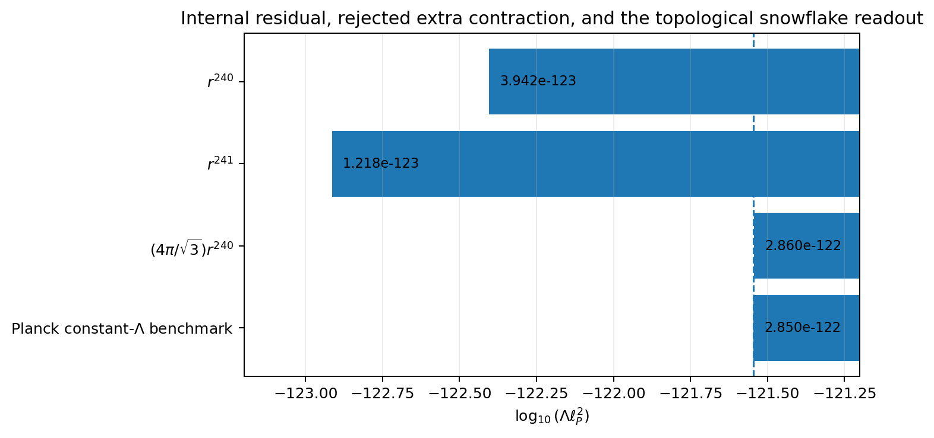
The topological snowflake readout, rather than an additional contraction, moves the internal residual to the observed constant-curvature scale.
The numerical comparison remains retrospective. The closure theorem is judged by the derivation of the factor, not by proximity alone.

12.2 Joining amplitude and density
The independent Unified Mechanics density remainder is
$$Ω_{DE}=0.6883222260935266….$$
For a flat constant-$Λ$ background,
$$λ_{∂}=3Ω_{DE}{\left(\frac{H_{0}ℓ_{P}}{c}\right)}^{2}.$$
Solving for $H_{0}$ gives
$$H_{0}=\frac{c}{ℓ_{P}}\sqrt{\frac{λ_{∂}}{3Ω_{DE}}}.$$
Substituting the two independently derived Unified Mechanics expressions yields
$$\boxed{H_{0}=67.36171745 km s^{−1} Mpc^{−1}}.$$
The corresponding curvature is
$$\boxed{Λ_{∂}=1.09495647×{10}^{−52} m^{−2}}.$$
The segment therefore closes as
$$\boxed{\text{density fraction}+\text{absolute root amplitude}+\text{boundary realization}→H_{0}}.$$

13. The final closure theorem
The full chain can now be written without the old ambiguity.
Golden contraction: $r$.
240-root joint event: $r^{240}$.
Minimal three-channel carrier: $A_{2}$.
Primitive local measure: $\sqrt{3}$.
Exhaustive root rendering: $40×6=240$.
Codimension-one realization: $2+1=3$.
Minimal closed orientable topology: $Σ≃S^{2}$.
Gauss–Bonnet:
Σ​K dA=4π.
Observer response integral:
$$λ_{∂}=\frac{4π}{\sqrt{3}}r^{240}.$$
Constant covariant realization:
$$T_{μν}^{\left(∂\right)}=−ε_{∂}g_{μν}.$$
MASTER THEOREM — Snowflake Realisation Closure. Assume the Unified Mechanics golden contraction, the physical 240-root carrier, root-local vacuum factorization, the minimal permutation-covariant three-channel observer representation, exhaustive $A_{2}$ rendering, codimension-one canonical completion, and scalar persistence. Then:
- the local observer carrier is uniquely $A_{2}$;
- its primitive measure is $\sqrt{3}$;
- the 240 roots have zero quantitative remainder under a forty-cell exact cover;
- the additional realization structure is one normal relation, not a 241st root;
- the canonical closed observer boundary has topology $S^{2}$;
- its total intrinsic curvature is $4π$;
- the external dimensionless curvature is
$$λ_{∂}=\frac{4π}{\sqrt{3}}r^{240};$$
- the covariant background stress has $w=−1$.
Within these representation conditions, the 240-root cosmological readout segment is closed end to end.

14. What this paper closes, and what remains outside it

14.1 Closed inside this segment
The paper removes four previous ambiguities.
There are not 241 roots. The root system is complete at 240.
The extra one is not another contraction. It is the rank-one normal relation of codimension-one realization and the single global boundary integral.
The factor $4π$ is not a chosen unit-sphere area. It is the topological curvature charge forced by Gauss–Bonnet for a genus-zero closed boundary.
The cosmological term has the correct stress tensor. Once the global record is constant, covariance forces the $w=−1$ form.

14.2 Obligations belonging to the wider framework
The following questions lie upstream or downstream of this segment and are not hidden by the closure theorem:
- Why is the physically realized internal carrier exactly the first $E_{8}$ root shell?
- Why is the vacuum state factorized over root-local contractions?
- Why does the observer representation satisfy the minimal-topology and scalar-persistence conditions in the real universe?
- Is dark energy exactly constant, or will future observations require a time-dependent extension?
- Can the same snowflake readout normalize an independent observable without any new factor?
Failure of any of these physical identifications would reject or modify the wider application. It would not alter the internal mathematics proved under the stated conditions.

15. Falsification and freeze conditions
The segment should be treated as frozen by the following equations:
$$r=\frac{1}{2φ},$$
$$P_{int}=r^{240},$$
$$A_{A_{2}}=\sqrt{3},$$
Σ​K dA=4π,
$$λ_{∂}=\frac{4π}{\sqrt{3}}r^{240},$$
$$Ω_{DE}=1−\frac{r^{2}}{2}−4r^{2}\left(1−r\right).$$
The construction fails as a physical model if:
- the observer carrier cannot be rank two;
- the three channel carrier is not permutation-covariant before weighting;
- the root shell cannot be exhaustively rendered by the local cell type;
- the completed boundary requires nonzero genus;
- the physical readout is not intrinsic curvature per primitive cell;
- the background scalar is observed to vary in a way incompatible with the constant action term;
- an independent test of the same readout requires changing the exponent, the $A_{2}$ measure, or the topological factor.
No factor of 40, no extra root, no $r^{241}$, and no alternative global area may be introduced after comparison.

16. Conclusion
The missing cosmological readout was not another root and not another traversal. It was a change from internal relation to external realization.
The 240 roots are fully exhausted:
$$240=40×6.$$
The local three-channel boundary alphabet is the $A_{2}$ snowflake. Its primitive measure is
$$\sqrt{3}.$$
The extra structure needed to render that rank-two carrier as the boundary of a three-dimensional object is one normal relation:
$$2+1=3.$$
Canonical completion adds no handles, so the closed boundary is topologically $S^{2}$. Gauss–Bonnet fixes its total intrinsic curvature:
Σ​K dA=4π.
The final observer record is therefore
$$\boxed{λ_{∂}=\frac{4π}{\sqrt{3}}r^{240}}.$$
The complete compression is:
$$\boxed{\text{The lattice supplies the suppression.}}$$
$$\boxed{\text{The snowflake supplies the primitive boundary measure.}}$$
$$\boxed{\text{The normal relation supplies three-dimensional realization.}}$$
$$\boxed{\text{Topology supplies the }4π\text{ curvature charge.}}$$
$$\boxed{\text{Covariance supplies vacuum stress.}}$$
The old 241 reader was not detecting a missing root. It was detecting that an internally complete system still required one whole-object realization before it could become a physical record. With that operation correctly typed, the 240-root observer-readout segment is mathematically closed under the explicit Unified Mechanics representation conditions.

Appendix A. Exact-cover verification
The accompanying verifier:
- regenerates the standard 240 doubled-coordinate $E_{8}$ roots;
- loads the forty certificate cells;
- checks six distinct norm-two roots per cell;
- checks sign closure;
- checks the $A_{2}$ form $\{±α,±β,±\left(α+β\right)\}$ with $α⋅β=−1$;
- checks no repeated root;
- checks equality with the complete standard root set.
The certificate establishes existence and exhaustion. The readout theorem is independent of the labels or uniqueness of the cover.

Appendix B. Numerical values
$$φ=1.618033988749895, r=0.3090169943749474.$$
$$r^{240}=3.942460771219664×{10}^{−123}.$$
$$\frac{4π}{\sqrt{3}}=7.255197456936871.$$
$$λ_{∂}=2.860333136142628×{10}^{−122}.$$
$$Ω_{DE}=0.6883222260935266.$$
$$H_{0}=67.3617174547 km s^{−1} Mpc^{−1}.$$
$$Λ_{∂}=1.0949564709×{10}^{−52} m^{−2}.$$

References
- Shields, J. Unified Mechanics: Consolidated Monograph. Working monograph, 2026.
- Shields, J. Snowflake Boundary Closure in Unified Mechanics: An $A_{2}$ Observer Readout of the 240-Root Vacuum Residual. Working paper, 2026.
- Dechant, P.-P. “The Birth of $E_{8}$ out of the Spinors of the Icosahedron.” arXiv:1602.05985 (2016).
- Gallier, J. “The Classification Theorem for Compact Surfaces and a Detour on Fractals.” arXiv:0805.0562 (2008).
- Chern, S.-S. “A Simple Intrinsic Proof of the Gauss–Bonnet Formula for Closed Riemannian Manifolds.” Annals of Mathematics 45 (1944): 747–752.
- Planck Collaboration. “Planck 2018 Results. VI. Cosmological Parameters.” Astronomy & Astrophysics 641, A6 (2020); arXiv:1807.06209.
- Mohr, P. J., Newell, D. B., Taylor, B. N., and Tiesinga, E. “CODATA Recommended Values of the Fundamental Physical Constants: 2022.” arXiv:2409.03787 (2024).

